**Python Programming**

**Mini Project Report**

**Panel :** A (A1 Batch)

**Group Members:**

|  |  |  |
| --- | --- | --- |
| **Name** | **Roll no** | **PRN** |
| Dharmika Tank | 02 | 1032210159 |
| Ananya Sharma | 12 | 1032210318 |
| Rohan Nair | 14 | 1032210342 |

**Guided by:** Prof. Anita Gunjal

**Problem Statement:** Tic Tac Toe game with GUI in python using Tkinter and also a restart functionality and displays which player turn now.

**Table of contents:**

|  |  |  |
| --- | --- | --- |
| **Sr no.** | **Heading** | **Page no.** |
| 1 | Introduction | 2 |
| 2 | Problem Statement | 2 |
| 3 | Short description of the Module | 2 |
| 4 | Tools/Libraries used | 3 |
| 5 | Output and Visualization screenshots | 10 |
| 6 | Limitations and Future Plan | 12 |
| 7 | Conclusion | 12 |
| 8 | References | 12 |
|  |  |  |

**Introduction**

This project is created using the Tkinter library of python. This game Tic-tac-toe ( noughts & crosses, or Os and Xs) is a pencil and paper game where two people participate O, and X. They take turns when marking the gaps of a 3×3 grid. The one that succeeds to place 3 of their marks vertically, horizontally, or diagonally wins.

Theory of Game:

A player can choose between two symbols with his opponent, usual games use “X” and “O”. If first player choose “X” then the second player have to play with “O” and vice versa.

If any player is able to draw three Xs or three Os in the following combinations then that player wins. The combinations are:

a) 1, 2, 3

b) 4, 5, 6

c) 7, 8, 9

d) 1, 4, 7

e) 2, 5,8

f) 3, 6, 9

h) 1, 5,9

i) 3, 5, 7

**Problem Statement:** Tic Tac Toe game with GUI in python using Tkinter and also a restart functionality and displays which player turn now.

**Short description of the Module**

Tkinter module:

* Tkinter is the standard GUI library for Python. Python when combined with Tkinter provides a fast and easy way to create GUI applications. Tkinter provides a powerful object-oriented interface to the Tk GUI toolkit.
* The tkinter module is a wrapper around tk, which is a wrapper around tcl, which is what is used to create windows and graphical user interfaces. Here, we show how simple it is to create a very basic window in just 8 lines. We get a window that we can resize, minimize, maximize, and close.

**Tools/Libraries used**

Geometry Management:

All Tkinter widgets have access to specific geometry management methods, which have the purpose of organizing widgets throughout the parent widget area. Tkinter exposes the following geometry manager classes: pack, grid, and place.

• The pack () Method − This geometry manager organizes widgets in blocks before placing them in the parent widget

• The grid() Method − This geometry manager organizes widgets in a table-like structure in the parent widget.

• The place () Method − This geometry manager organizes widgets by placing them in a specific position in the parent widget.

Tkinter provides various controls, such as buttons, labels and text boxes used in a GUI application. These controls are commonly called widgets. Following are the functions tkinter provides which we are using in our project for displaying.

|  |  |
| --- | --- |
| **Sr.No.** | **Operator & Description** |
| 1 | [Button](https://www.tutorialspoint.com/python/tk_button.htm)  The Button widget is used to display buttons in your application. |
| 2 | [Check button](https://www.tutorialspoint.com/python/tk_checkbutton.htm)  The Check button widget is used to display a number of options as checkboxes. The user can select multiple options at a time. |
| 3 | [Entry](https://www.tutorialspoint.com/python/tk_entry.htm)  The Entry widget is used to display a single-line text field for accepting values from a user. |
| 4 | [Frame](https://www.tutorialspoint.com/python/tk_frame.htm)  The Frame widget is used as a container widget to organize other widgets. |
| 5 | [Label](https://www.tutorialspoint.com/python/tk_label.htm)  The Label widget is used to provide a single-line caption for other widgets. It can also contain images. |
| 6 | [Listbox](https://www.tutorialspoint.com/python/tk_listbox.htm)  The Listbox widget is used to provide a list of options to a user. |
| 7 | [Menubutton](https://www.tutorialspoint.com/python/tk_menubutton.htm)  The Menubutton widget is used to display menus in your application. |
| 8 | [Menu](https://www.tutorialspoint.com/python/tk_menu.htm)  The Menu widget is used to provide various commands to a user. These commands are contained inside Menubutton. |
| 9 | [Message](https://www.tutorialspoint.com/python/tk_message.htm)  The Message widget is used to display multiline text fields for accepting values from a user. |
| 10 | [Radiobutton](https://www.tutorialspoint.com/python/tk_radiobutton.htm)  The Radiobutton widget is used to display a number of options as radio buttons. The user can select only one option at a time. |
| 11 | [Scale](https://www.tutorialspoint.com/python/tk_scale.htm)  The Scale widget is used to provide a slider widget. |
| 12 | [Scrollbar](https://www.tutorialspoint.com/python/tk_scrollbar.htm)  The Scrollbar widget is used to add scrolling capability to various widgets, such as list boxes. |
| 13 | [Text](https://www.tutorialspoint.com/python/tk_text.htm)  The Text widget is used to display text in multiple lines. |
| 14 | [Toplevel](https://www.tutorialspoint.com/python/tk_toplevel.htm)  The Toplevel widget is used to provide a separate window container. |
| 15 | [Spinbox](https://www.tutorialspoint.com/python/tk_spinbox.htm)  The Spinbox widget is a variant of the standard Tkinter Entry widget, which can be used to select from a fixed number of values. |
| 16 | [PanedWindow](https://www.tutorialspoint.com/python/tk_panedwindow.htm)  A PanedWindow is a container widget that may contain any number of panes, arranged horizontally or vertically. |
| 17 | [LabelFrame](https://www.tutorialspoint.com/python/tk_labelframe.htm)  A labelframe is a simple container widget. Its primary purpose is to act as a spacer or container for complex window layouts. |
| 18 | [tkMessageBox](https://www.tutorialspoint.com/python/tk_messagebox.htm)  This module is used to display message boxes in your applications. |

**Output and Visualization screenshots**

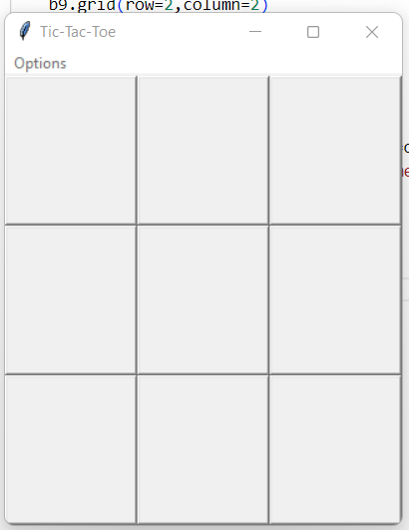

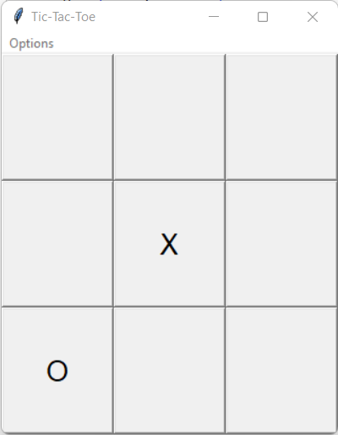

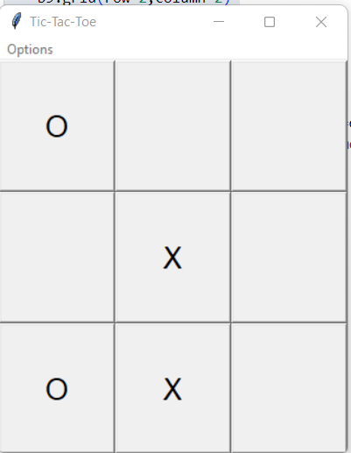

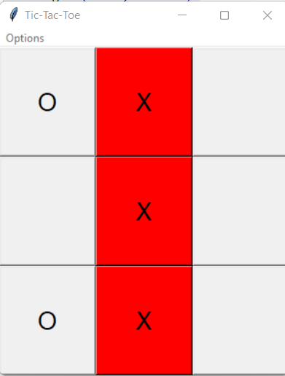

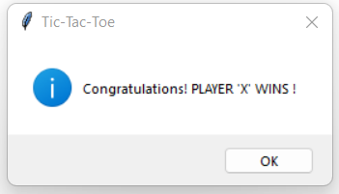

**Limitations:**

1. GUI is not so attractive.

2. Only mouse interface is implemented, keyboard is not activated in the game.

**Future plan:**

1. Keyboard functions will be added.

2. We want to design more complex boards for the game in future.

3. Allow the user to select the mode of the game(whether the user wants to play with a friend or with the computer).

4. Allow the user to define the matrices.It can be 2*2 or 3*3 or n*n matrix.

**Conclusion:**

We explored that a pen-paper game can be played on electronic device. We learned the logic which decides the winner of the game. Tic-Tac-Toe game cam be made using GUI in Python using Tkinter.

**Reference:**

Books:H.M.Deitel and P.J.Deital, Java How to program: Sixth EditionHerbert Schildt, The Complete Reference: Fifth edition